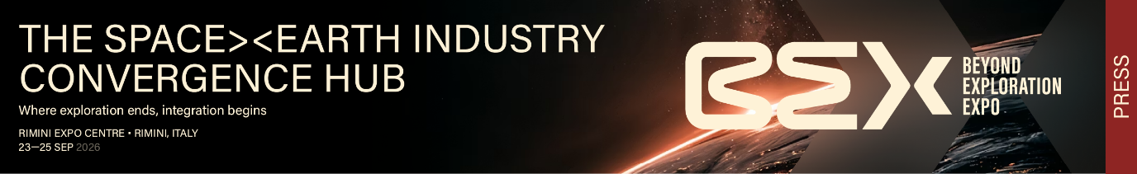
nota stampa

BEX – BEYOND EXPLORATION EXPO PREVIEWS AT KEY 2026 THE SPACE ECONOMY MEETS THE ENERGY TRANSITION

- At KEY – The Energy Transition Expo (Rimini, 4–6 March 2026), a preview of Italian Exhibition Group's first event dedicated to the space economy
- The event, which will make its debut at Rimini Expo Centre from 23–25 September, will be introduced to the energy transition community through a dedicated desk and a conference on the synergies between space and green technology
- Announced: collaboration with ASI, which has granted its patronage to the event, for a university hackathon

Rimini, 27 February 2026 – BEX – Beyond Exploration Expo, Italian Exhibition Group's new event dedicated to the space economy, will be present at KEY – The Energy Transition Expo 2026 with a dedicated desk and a conference on the points of convergence between space technologies and the energy transition. A preview that anticipates by six months the official debut scheduled in Rimini from 23 to 25 September 2026.

Space technologies are today a strategic asset for the energy transition: satellite data enable real-time monitoring of energy infrastructure, optimisation of distribution networks, high-precision weather forecasting for the management of renewable energy plants, and support for agrivoltaics through Earth observation. An intersection of expertise and markets that BEX intends to develop by building a bridge between the space industry and sectors with high application potential.

The conference "Energy for Space or Space for Energy?", organised with ASI – Italian Space Agency, ENEA and with the participation of ESA – European Space Agency, scheduled at KEY on 4 March 2026 (3:00–4:00 PM, RENEWABLES HUB, Pavilion A7, in media partnership with Rinnovabili.it), will explore the bidirectional relationship between energy and space, highlighting technological challenges, concrete business opportunities and emerging business models where public and private actors can collaborate. The session will be moderated by Matteo Spagnolo, CEO of Rinnovabili.it. Speakers will include Girolamo Di Francia, Head of the Energy and Data Science Laboratory at ENEA, and Simone Pirrotta from the Science and Innovation Directorate at ASI. The programme will also feature a presentation of business opportunities for companies by Beatrice Barresi of the ESA ACCESS Programme, and a contribution from Elena Bonacini of BEX on the new hub dedicated to the Space Economy.

The presence at KEY will also be the occasion to announce a significant collaboration with ASI – Italian Space Agency, which will contribute to the organisation of a hackathon for university students, with the aim of stimulating the development of innovative solutions at the intersection of space and sustainability.

"The space economy is not an isolated sector, but a cross-cutting ecosystem that generates value for industries that are only apparently distant," says Alessandra Astolfi, Global Exhibition Director of IEG's Green & Technology division. "KEY represents the ideal context in which to introduce BEX to energy transition operators. Satellite technologies and geospatial data are already indispensable tools for those working in renewables, energy efficiency and environmental monitoring. The conference we are organising will be an opportunity to bring these worlds into dialogue and build concrete business opportunities."

BEX – Beyond Exploration Expo is Italy's first trade show entirely dedicated to the space economy. Scheduled in Rimini from 23 to 25 September 2026, BEX positions itself as an international reference hub for the meeting point between the traditional space industry (upstream), downstream applications and non-space sectors interested in the opportunities offered by space technologies. The event features exhibition areas, conferences, technical workshops, matchmaking sessions and a dedicated area for start-ups, universities and research centres.

PRESS CONTACT IEG
head of media relation & corporate communication: Elisabetta Vitali; press office manager: Marco Forcellini, Pier Francesco Bellini; press office coordinator: Luca Paganin; press office specialist: Mirko Malgieri; press office assistant: Julia Andreatta media@iegexpo.it;

MEDIA AGENCY BEX - BEYOND EXPLORATION EXPO: MEP S.r.l.
Leonardo Vivard - leonardo.vivard@mep.it - mob. +39 3897652135 Valentina Impellizzeri - valentina.impellizzeri@mep.it - mob +39 3806366514

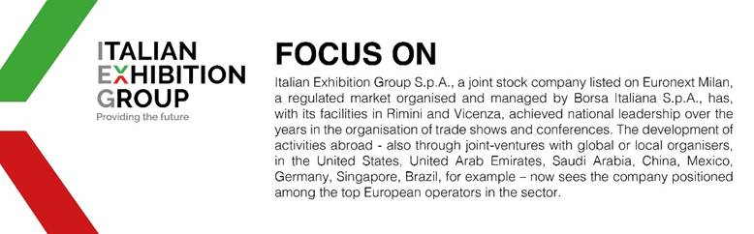
This press release contains forecast elements and estimates that reflect the management’s current opinions (“forward-looking statements”), particularly regarding future management performance, realization of investments, cash flow trends and the evolution of the financial structure. For their very nature, forward-looking statements have a component of risk and uncertainty, as they depend on the occurrence of future events. The effective results may differ (even significantly) from those announced, due to numerous factors, including, only by way of example: food service market and tourist flow trends in Italy, gold and jewellery market trends, green economy market trends; the evolution of raw material prices; general macroeconomic conditions; geopolitical factors and evolutions in the legislative framework. Moreover, the information contained in this release does not claim to be complete, and has not been verified by independent third parties. Forecasts, estimates and objectives contained herein are based on the information available to the Company as at the date of this release.

