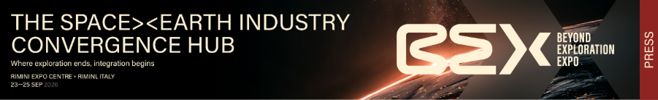

SPACE ECONOMY, ITALIAN EXHIBITION GROUP LAUNCHES BEX - BEYOND EXPLORATION

- From 23 to 25 September 2026 at Rimini Expo Centre, the first edition of the new expo-conference promoted by IEG in collaboration with the Emilia-Romagna Region;
- An international, multidisciplinary event conceived as a catalyst for ideas and business, aimed at companies from the space and terrestrial industries, universities, start-ups and institutions;
- A B2B format combined with scientific and public-engagement sessions, designed to inspire the next generation of students and industry professionals;
- An Open Innovation District dedicated to the entire innovation ecosystem, and a groundbreaking project – The Astronaut's Home – bringing the daily challenges of life in space to the show floor as a laboratory of solutions for terrestrial industries.

Rimini, 10 March 2026 – Satellite data optimising agricultural yields, materials engineered to withstand the extreme conditions of space now insulating buildings and cutting energy consumption, geolocation systems directing the logistics of half the planet, remote monitoring technologies born for astronauts now accelerating telemedicine: space has never been so present in the real economy. And the need to build a place where these two worlds can meet has never been more urgent.

From 23 to 25 September 2026, Rimini Expo Centre will host the first edition of BEX – Beyond Exploration, the international expo-conference dedicated to the Space Economy and the convergence between the space industry and terrestrial industry, promoted by IEG – Italian Exhibition Group. BEX is born to position Italy at the centre of the international debate on space, with the ambition of becoming the European reference point where industry, research, institutions and new sectors together chart the trajectories of the next economy. Because value is not created solely from space to Earth, nor solely from Earth to space: it is created at the meeting point. The event combines B2B business with outreach and training sessions, opening its doors to universities, researchers and future professionals. Its objective is to stimulate dialogue between the traditional space supply chain, emerging industrial sectors and the entire innovation ecosystem – fostering cross-pollination between seemingly distant fields, from food to fashion, from health to logistics, from automotive to energy.

"BEX – explains Professor Giuseppe Sala, Professor at the Department of Aerospace Science and Technology at Politecnico di Milano and President of the event's Scientific and Technical Committee – is set to represent a genuine breakthrough in the landscape of events dedicated to space exploration and the space economy. The project, developed by a team of experts from complementary disciplines, aims to go beyond traditional formats and establish itself as an international point of reference. It will not merely be a networking opportunity for companies and institutions,but will also open its doors to the public – the true end-user of space services. The objective is to integrate worlds that are only apparently distant – from food to fashion, from pharmaceuticals to healthcare and wellness – through to sectors ripe for reinvention, such as automotive. All of this will take shape through exhibition spaces, networking and matchmaking sessions, public lectures, specialist workshops and student hackathons."

Also noteworthy is the contribution of Colonel Walter Villadei, professional astronaut of the Italian Air Force and BEX Ambassador: "Space is changing fast. It is a crossroads of economic, scientific, industrial, geopolitical and military interests. There is a need – and increasingly so in the future – for multidisciplinary meetings and dialogue to support growth and innovation, as well as to seek sustainability solutions for major global challenges. I am therefore truly delighted to serve as Ambassador for this important initiative, which demonstrates that Italy has the resources, vision and creativity to chart new trajectories for the benefit of the international community. An event that will put young people and schools centre stage, drawing them ever closer to the world of aerospace."

BEX will cover the entire supply chain: from components and launch systems through to orbital stations (upstream), encompassing non-traditional industrial sectors discovering new commercial opportunities in space, and extending to satellite data-based services already transforming agriculture, mobility, energy and security (downstream). Significant focus will also be dedicated to the development of autonomous multi-domain systems (space, aeronautics, underwater, terrestrial), both as operational solutions and as test platforms for technological and industrial innovation.

The event will also feature a cross-sector area – the Open Innovation District – dedicated to start-ups, universities, research centres, government agencies, venture capital, incubators and business accelerators, reflecting the commitment to engaging the entire innovation ecosystem. BEX will also be home to The Astronaut's Home, a project with a completely original perspective: the fundamental needs of life in space – sleeping, eating, exercising, healthcare, getting dressed – as a driver of industrial innovation. In space, every everyday function becomes an engineering challenge requiring radically new solutions. Those same solutions, once developed, can unlock concrete opportunities for terrestrial industries.

In support of BEX's international reach, IEG has opened discussions with the Ministry of Enterprises and Made in Italy (MIMIT), the Ministry of Economy and Finance (MEF), the Ministry of Foreign Affairs and International Cooperation (MAECI), the National Research Council (CNR) and the Presidency of the Council of Ministers (PCM). The Italian Space Agency (ASI) and the Italian Air Force have already confirmed their patronage, joining the leading governmental, regional and sector trade associations.

BEX thus positions itself as a strategic platform to catalyse the future of the space economy in Italy and across Europe, integrating sectors, players and visions within a genuinely interdisciplinary and forward-looking perspective.

PRESS CONTACT IEG
head of media relation & corporate communication: Elisabetta Vitali; press office manager: Marco Forcellini, Pier Francesco Bellini; press office coordinator: Luca Paganin; press office specialist: Mirko Malgieri; press office assistant: Julia Andreatta media@iegexpo.it;

MEDIA AGENCY BEX - BEYOND EXPLORATION EXPO: MEP S.r.l.
Leonardo Vivard - leonardo.vivard@mep.it - mob. +39 3897652135 Valentina Impellizzeri - valentina.impellizzeri@mep.it - mob +39 3806366514

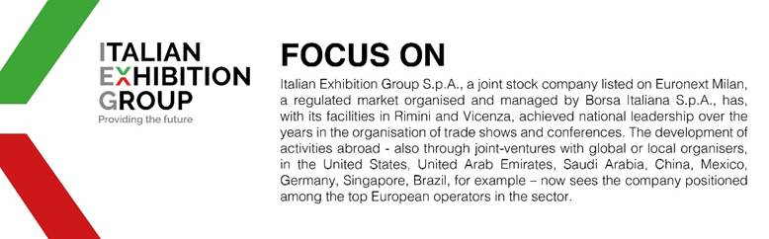

This press release contains forecast elements and estimates that reflect the management’s current opinions (“forward-looking statements”), particularly regarding future management performance, realization of investments, cash flow trends and the evolution of the financial structure. For their very nature, forward-looking statements have a component of risk and uncertainty, as they depend on the occurrence of future events. The effective results may differ (even significantly) from those announced, due to numerous factors, including, only by way of example: food service market and tourist flow trends in Italy, gold and jewellery market trends, green economy market trends; the evolution of raw material prices; general macroeconomic conditions; geopolitical factors and evolutions in the legislative framework. Moreover, the information contained in this release does not claim to be complete, and has not been verified by independent third parties. Forecasts, estimates and objectives contained herein are based on the information available to the Company as at the date of this release.

