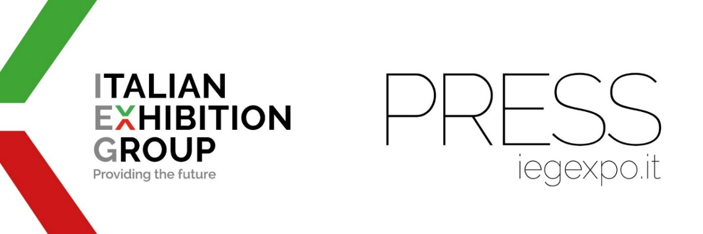
press release
SPACE ECONOMY, ITALIAN EXHIBITION GROUP LAUNCHES BEX - BEYOND EXPLORATION

- From 23rd to 25th September 2026 at Rimini Expo Centre, the first edition of the new expo-conference promoted by IEG in collaboration with the Emilia-Romagna Region;
- An international and multidisciplinary event designed as a catalyst for ideas and business and aimed at companies operating in the space industry or other, universities, start-ups and institutions;
- A B2B format that includes scientific and informative meetings to inspire new generations of students and sector professionals;
- From memory foam mattresses, to anti-glare glasses and wi-fi, everything you would not expect that was originally devised for aerospace and then became of common use.
Rimini, 16th October 2025 - Numerous technologies created specifically for use in aerospace are now in common use today: from memory foam mattresses to anti-glare glasses, from wi-fi to telemedicine, miniature smartphone cameras, biometric sensors and the wireless vacuum cleaner which draws its technology from the portable collection systems designed for the Apollo missions. But think also about satellites, for example, and their fundamental use in environmental monitoring, mobility, safety, energy and agriculture.
From 23rd to 25th September 2026, Rimini Expo Centre will be hosting the first edition of BEX – Beyond Exploration, the expo-conference specifically for the space economy and commercial space flight, promoted by IEG - Italian Exhibition Group in collaboration with the Emilia-Romagna Region. BEX was created to position Italy at the centre of the international debate on space and aims to become the European reference point where ideas, innovative projects and partnerships between industry, research, institutions, and new sectors converge. The event will feature an innovative organization that combines B2B business with information and training moments: not only networking between companies and institutions, but also space for schools and students. The objective of BEX is to stimulate dialogue between the traditional space supply chain, emerging industrial sectors and the entire research and innovation ecosystem, fostering cross-contamination between apparently distant fields such as food, fashion, health, logistics and the automotive industry.
“BEX,” explains professor Giuseppe Sala from the Department of Aerospace Sciences and Technologies at Milan Polytechnic and president of the event’s Scientific Technical Committee, “is preparing to be an absolute first in the panorama of events dedicated to space exploration and the space economy. The project, developed by a group of experts from complementary disciplines, aims to overcome traditional formats and become an international point of reference. Not only will it be an opportunity for networking between companies and institutions, it will also open its doors to the public, the real end user of space services. The objective is to integrate apparently distant worlds - from food to fashion, pharmaceuticals, healthcare and wellness – and even sectors in need of reconversion such as the automotive industry... All this will take shape through exhibition areas, networking and matchmaking moments, informative lessons, specialist workshops and hackathons for students."
The statement from Colonel Walter Villadei, professional Italian Air Force astronaut and BEX “Ambassador” also stands out: “Space is rapidly transforming. A crossroads of economic, scientific, industrial, geopolitical and military interests. There is a need, which will be ever-increasing in the future, for opportunities for multidisciplinary meetings and dialogue to support growth and innovation, as well as to find sustainability solutions for major global issues. I am therefore really pleased to be able to act as "Ambassador" for this important initiative, which demonstrates how Italy has the resources, planning and creativity to define new trajectories for the international community. An event that will see young people and schools in a leading role in order to bring them ever closer to the aerospace world.”
BEX will host vertical focuses on the traditional space supply chain (upstream: transport systems, propulsion, space modules and orbiting stations), on the emerging multidisciplinary supply chain - i.e. non-traditional sectors that see new commercial and technological development opportunities in space. And on everything related to the use of satellite data for advanced services to Earth (downstream). Great attention will be paid to the development of autonomous multi-domain systems (space, aeronautics, underwater, land), both as operational solutions and as test platforms for technological and industrial innovation.
The event will also host a transversal area (“Beyond Nxt”) for start-ups, universities, research centres, government agencies and NGOs, confirming the desire to involve the entire innovation ecosystem.
To reinforce the international reach of BEX, IEG is already in discussions with the Ministry of Enterprise and Made in Italy (MIMIT), the Ministry of Economy and Finance (MEF), the National Research Council (CNR), the Presidency of the Council of Ministers (PCM), the Italian Space Agency (ASI) and the Air Force, with a view to obtaining partnerships and institutional sponsorship for the success of the initiative.
BEX will therefore be a strategic platform to invigorate the future of the space economy in Italy and Europe by integrating sectors, players and visions in a truly interdisciplinary and visionary perspective.

PRESS CONTACT ITALIAN EXHIBITION GROUP | media@iegexpo.it
head of corporate communication & media relation: Elisabetta Vitali| press office manager: Marco Forcellini, Pier Francesco Bellini | international press office coordinator: Silvia Giorgi | press office coordinator: Luca Paganin | press office specialist: Nicoletta Evangelisti, Mirko Malgieri
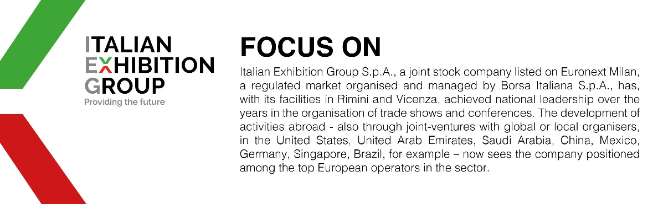

This press release contains forecast elements and estimates that reflect the management’s current opinions (“forward-looking statements”), particularly regarding future management performance, realization of investments, cash flow trends and the evolution of the financial structure. For their very nature, forward-looking statements have a component of risk and uncertainty, as they depend on the occurrence of future events. The effective results may differ (even significantly) from those announced, due to numerous factors, including, only by way of example: food service market and tourist flow trends in Italy, gold and jewellery market trends, green economy market trends; the evolution of raw material prices; general macroeconomic conditions; geopolitical factors and evolutions in the legislative framework. Moreover, the information contained in this release does not claim to be complete, and has not been verified by independent third parties. Forecasts, estimates and objectives contained herein are based on the information available to the Company as at the date of this release.

